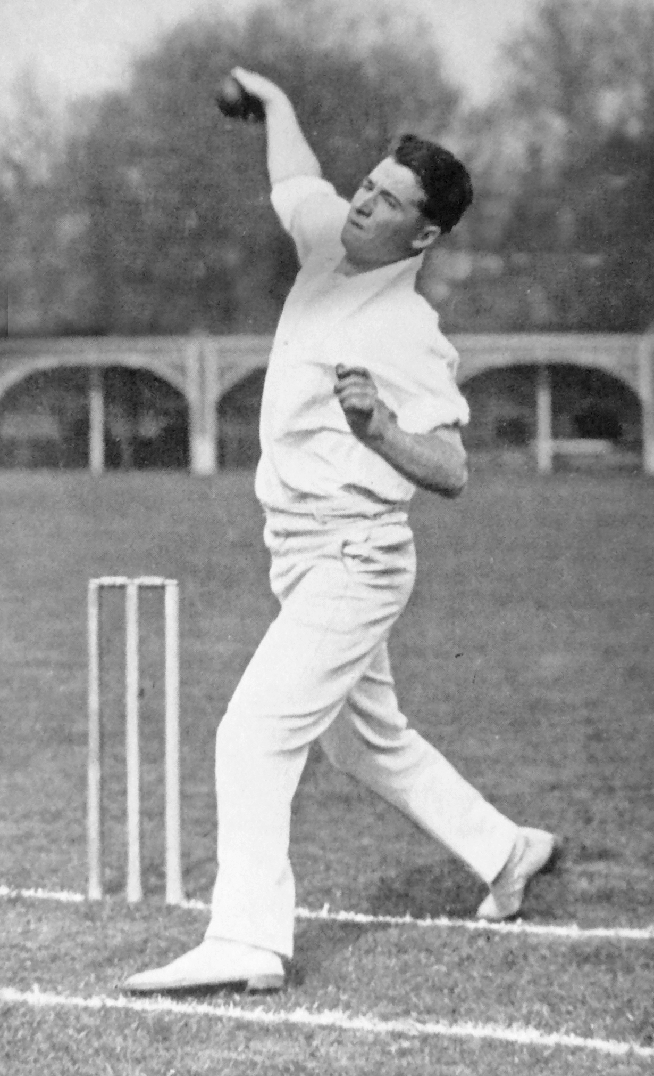 **Bill Merritt bowling in 1931**